**Ma’lumotlar tuzilmasi va algoritmi**

**F.I.SH. Omonbayev Jaloliddin Ravshanbek o’g’li**

**Guruh: 911-21 guruh talabasi**

**Amaliyot: 6**

**Misol: 2**

**Dasturlash tili: C++ CodeBlocks**

**1_2 . Massiv o’suvchi yoki kamayuvchi ekanini tekshiruvchi funksiya shablonini yarating.**

#include <bits/stdc++.h>

using namespace std;

void checkType(int arr[], int n) {

if (arr[0] <= arr[1] && arr[n - 2] <= arr[n - 1])

cout << "Ortib bormoqda";

else if (arr[0] >= arr[1] && arr[n - 2] >= arr[n - 1])

cout << "Kamaymoqda";

else if (arr[0] <= arr[1] && arr[n - 2] >= arr[n - 1])

cout << "Ko'tariladi, keyin kamayadi";

else cout << "Massiv o'sish tartibida";}

int main() {

int n;

cout<<"n=";cin>>n;

int arr[1000];

for(int i=1;i<=n;i++){

cin>>arr[i];}

checkType(arr, n);

return 0; }

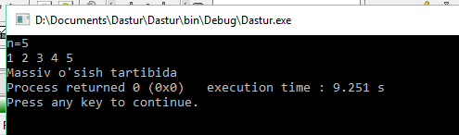

1. **Massiv hamma elementlarining o’zaro tengligini tekshiruvchi funksiya shablonini yarating**

#include <bits/stdc++.h>

using namespace std;

bool areSame(int arr[], int n)

{

int first = arr[0];

for (int i = 1; i < n; i++)

if (arr[i] != first)

return 0;

return 1;

}

int main()

{

int arr[] = {1, 2, 3, 4};

int n = sizeof(arr) /

sizeof(arr[0]);

if (areSame(arr, n))

cout << "Massiv elementlari o'zaro teng";

else

cout << "Massiv elementlari teng emas";

}

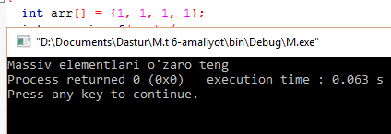

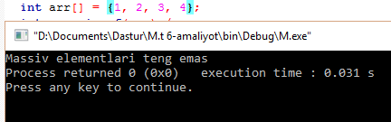

**4.** **Show_array funksiyasi shablonidan foydalanib massiv elementlarini chiqarish.**

#include <bits/stdc++.h>

using namespace std;

void show_array(int arr[], int size)

{

static int i;

if (i == size) {

i = 0;

cout << endl;

return;}

cout << arr[i] << " ";

i++;

show_array(arr, size);}

int main(){

int arr[] = { 3, 5, 6, 8, 1 };

int n = sizeof(arr) / sizeof(arr[0]);

show_array(arr, n);

return 0;}

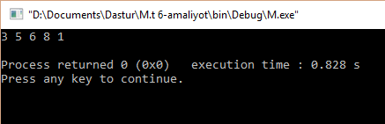

5.Ma’lum bir ishni bajaruvchi bitta va bir nechta konstruktordan iborat sinflar yaratish va ularni qo’llashga doir misollar

#include <iostream>

using namespace std;

class student {

int rno;

char name[50];

double fee;

public:

student();

void display();

};

student::student()

{

cout << "Tartib raqamini kiriting:";

cin >> rno;

cout << "Ismni kiriting:";

cin >> name;

cout << "To'lovni kiriting:";

cin >> fee;

}

void student::display()

{

cout << endl << rno << "\t" << name << "\t" << fee;

}

int main()

{

student s;

s.display();

return 0;

}

